**Unit 6**　**Meet My Family!**

**Part B** (**1**)

词汇 积累练

一、开动脑筋，你一定能填上。(20分)

1.QQ截图20121206093055　　　　　 2.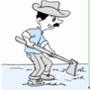

　n____ ____se　　　 farm____ ____

3.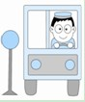 4.

　dr____ver　　　　 d____ct____r

语句 应用练

二、你会搭配吗？(词图一致。)(30分)

(　　)1.Act like a teacher.

(　　)2.Act like a farmer.

(　　)3.Act like a driver.

(　　)4.Act like a doctor.

(　　)5.Act like a nurse.

(　　)6.Act like a baseball player.

A.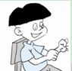　　　 B. C.

D.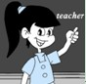 E. F.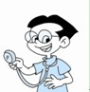

情景 交际练

三、想一想，选一选。(30分)

(　　)1.当你想问别人的妈妈的职业是什么时，你应说：________

A．What is your mother? B．Where is your mother?

(　　)2.当你向别人介绍你姐姐的爱好时，你应说：________

A．My sister like music. B．My sister likes science.

(　　)3.当你想说“像医生一样表演”时，你应说：________

A．Act like a driver. B．Act like a doctor.

竞赛 提升练

四、小练笔。(20分)

介绍一下你的家庭，至少5句话。



(男)司机　 学生　　 (女)护士

strong　　　　 thin　　　　 quiet

My Family

There are 3 people in my family.They're my parents and me.My________．He________．My ________．She ________．I ________．I ________．I love my family.

**答案全析全解**

一、1.u，r　2.e，r　3.i　4.o，o

二、1.D　2.B　3.A　4.F　5.C　6.E

三、1.A　2.B　3.B

四、My Family

There are 3 people in my family.They're my parents and me.My father is a driver.He's strong.My mother is a nurse.She's quiet.I am a student.I am thin.I love my family.